#### TESTING METHODOLOGIES:

##### Q: Who is responsible for testing. At what level the Test Engg.. will involve in testing

They are of three types

1. Black box testing
2. White box testing
3. Grey box testing
   1. **Black box testing:**

If the resource is performing testing on the functional part of the application, then he will be treated as “*Black box tester*”.

Functional part means whether the developed application is as per the client’s requirements or not. Testers will perform black box testing in test environment and stage env (Pre production env)

* 1. **White box testing:**

If the resource is testing the structural part (programming) of the application, then he will be treated as *“white box tester*”. Developers are responsible for white box testing in development environment.

* 1. **Grey box testing:**

If the resource is having the experience on both testing (white box testing and black box testing). Then he will be treated as “*Grey box tester*”.

## LEVELS OF TESTING:

If one project has to go from the signoff stage to live(production), it has to undergo the below levels of testing.

1. **Unit level of testing**
2. **Module level testing**
3. **Integration level of testing**
4. **UAT(User acceptance testing)**
5. **System testing**
6. **Unit level of testing:** *Unit* means the smallest flow or scenario in the application.
   * Developer is responsible for Unit level testing.
   * He will divide the assigned module to multiple units and develops the code for all the units.
   * He is responsible to check whether each and every unit is working as expected or not.
7. **Module level testing:**
   * From Module level testing, both testing team and development team is responsible.
   * The developer will combine all the related units to form a module.
   * Once the module is developed, the developer is responsible for white box testing in development environment.
   * Once the module is released to the testing team, they are responsible for Black box testing in testing environment.
8. **Integration level testing:**
   * The process of combining all the developed modules is known as *integration*.
   * Check whether the data flow is navigating from one module to other is known as

*integration level testing*.

* + Both development team and testing team is responsible for integration level testing.

Ex: Create one account in Gmail, check that whether you are able to login into the application with created account. Then compose mail and send it, check that whether it is properly delivered or not.

* While integration if any mandatory moduleis missing then the development Lead will replace the mandatory module with some dummy code is known as stub or driver.

+ + + +

D1

D2

D3

D4

+

D5

Credentials Login Compose Send Logout



**Stub/Driver:**Both are nothing but a dummy code, it doesn't contain any functionalities.

* If the development lead is using top down approach to integrate the modules, while integration if any mandatory module is missing then it will be replaced by *Stub*.
* If the development lead is using bottom up approach to integrate the modules, while integration if any mandatory module is missing then he will replace with *Driver.*

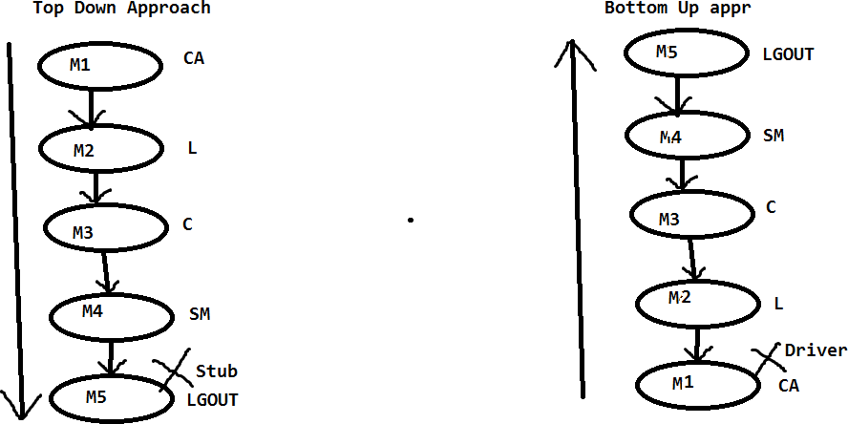

1. **User Acceptance Testing:**
   * It is known as *user/client acceptance testing*. Once the build is stable in test environment then we willplanto deliver the build to the client. Before delivering the build to the client, the client will send User acceptance test cases to the testing team for execution.
   * The testing team will execute all the UA test cases in test environment; if all are passed then the project manager will deliver the build to the client.
   * Client again will execute all the UA test cases in the client’s environment (stage environment). If all are passed then the client will deploy the build in the Live or Production environment.
   * UAT is of two types:

**a.**Alpha Testing

**b.** Beta Testing **UAT**



**Alpha testing Beta testing** (UATCS)

(UATCs) Test environmentStage Environment

1. **Alpha Testing:**Executing all the UA test cases in a test environment by the testing team is known as ‘*Alpha testing’*.
2. **Beta Testing:** Executing all the UA test cases in the clients Stage environment by the client’s team or the testing team is known as ‘*Beta testing’*.

Once the Beta testing is passed then the client will go to the live environment. Test Environment Client



UATCS

Start

Testing Team Build

Build (UATCS) pass Deliver

#### System Testing:

* + It is also known as *non-functional testing*. Once the application is stable, then we can go for non-functional testing.
  + In non-functional testing performance (response time) of the application will be identified.
  + The time taken between the request and response is known as *response time*. It will be identified with the help of multiple non-functional testing types like Load testing, Performance testing, Stress testing, Breaking point testing.

